**Machine Learning**

**Practical List**

**Practice 1: Write a python code to implement decision tree for below given dataset identify the root node and all subpart or children of node and draw the tree.**

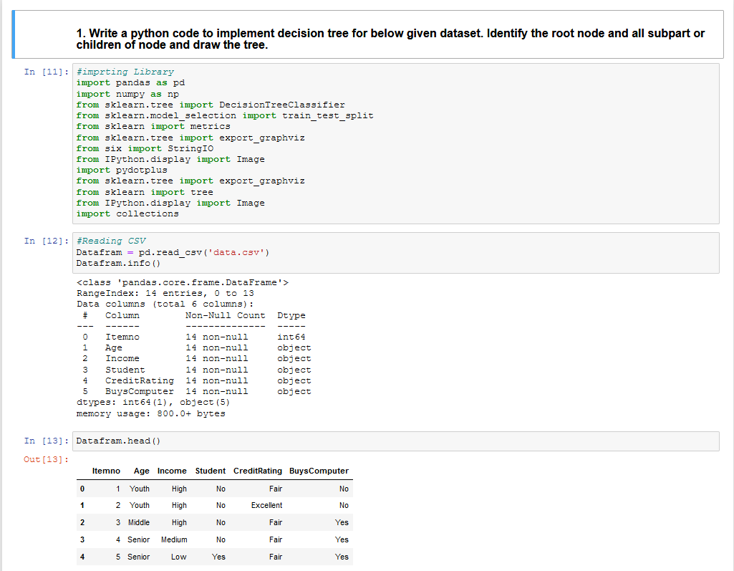

* Transforming String to integer value for better train and working with decision tree algorithm
* Also, we train over model with data. The data which is available in data.csv file.
* Accuracy of model that are trained in code is 100%, so we can say that the model is perfect for any kind of condition.
* Hear we implemented decision tree with dependent variable BuysComputer column of the data set to other independent variables Income, Age, Student, CreditRating.

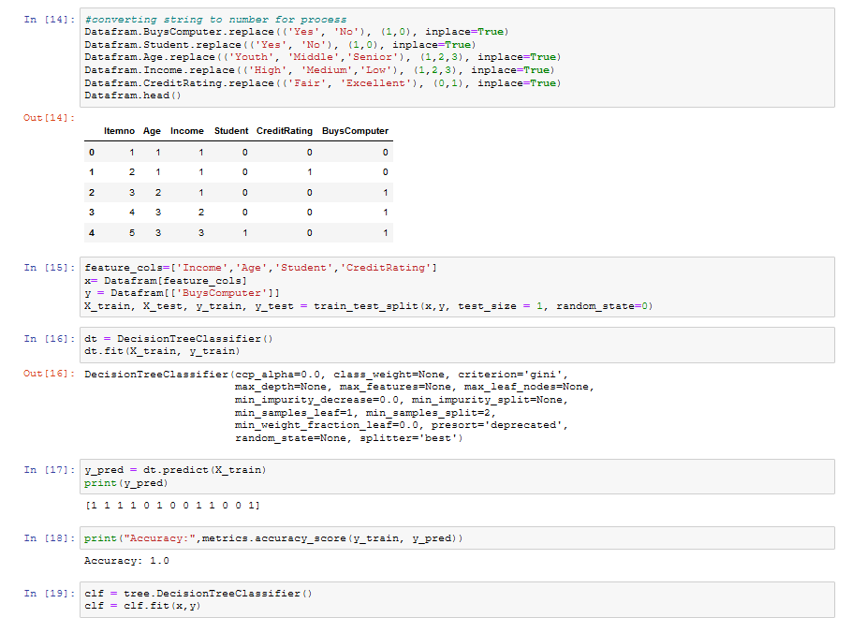

**Error’s:** Graphviz Executables cannot be found.

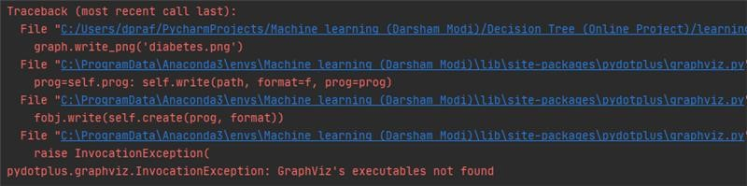

**Solution**: Generally, it happens after installation of graphviz Due to graphviz library doesn’t exist in Environment variables – Path You have to add path of the graphviz directory in environment variable (path like: C:\Users\dpraf\anaconda3\Library\bin\graphviz)

